Training materials for seminars on Molecular-biochemical markers of plants to disease resistance
Speciality biotechnology
The title of seminars

Module 1 Structure, feature and functions of nucleic acids
Seminar 1. Biochemical markers of disease resistance.
The post infection resistance (active resistance) might be correlated with
specific biochemical changes in phenols, sugars, amino acids, phytoalexin
accumulation, lignifications and activation of oxidative enzymes in host plant
(Metraux and Raskin, 1992). Also, the accumulation of host synthesized new
polypeptides is associated with the disease resistance. (Broglie et al.,
1986).The new protein contents depended on host genotype and virulence
genes of the pathogens (Hlinkova and Sykora,1996).
The resistant interaction, in plants, involves accumulation of antibiotic compound phytoalexin (Genestein in Vigna radiata) and induction of enzymes such as β-1,3 gulcanase and Chitinases. These compounds are not only induced by pathogens but also pathogen-derived elicitors. These biochemical compounds can be used as resistance indicative biochemical markers for screening the natural or mutagen induced genetic diversity in populations of Vigna radiata in non-destructive manner.
Plant pathologists and breeders as to the potential use of biochemical markers in breeding programs. Marker identification, as evidence of the presence or an indication of the character, is the basic approach adopted to bring together a broad spectrum of possibilities to detect resistance by means of "biochemical" assays rather than by the conventional "biological" host-pathogen interactions, as expressed by artificial or natural inoculations. Peroxidase (POX) activity is frequently increased in plants infected by pathogens, and the level of its activity is often closely correlated with disease resistance, as documented by T. Kosuge more than 20 years ago. In lettuce, a trend was apparent indicating that one component of field resistance to Bremia lactucae could be related to a high level of POX prior to infection. Chitinase, a hydrolase with an antifungal potential, is one of the pathogenesis-related proteins which is induced in cucumber seedlings94 or tobacco plants in response to infections producing necrotic symptoms.

Reuven Reuveni. Biochemical Markers for Disease Resistance *
Book Molecular Methods in Plant Pathology
Edition 1995 Imprint CRC Press
Seminar 2. Cyclic adenosine monophosphate (cAMP). Mitogen-activated protein kinases (MAPKs
Recognition
- Initiates after the host and the pathogen come in contact with each other
- Indicates some kind of communication between the two
- Begins with onset of biochemical reactions in one or both the interacting units
- Signal- sensor reaction
Singals
- Host components acting as signals for recognition by
- and activation of pathogens are numerous e.g. cutin,
- galacturonans,
The perception of signals
- The perception of signals from plant surfaces by pathogenic fungi is the result of signaling pathways mediated by:
- cyclic adenosine monophosphate (cAMP)
- and mitogen-activated protein kinase (MAPK),
which have been implicated in regulating the development of infection-related phenomena in many different fungi.
for early identification of F. oxysporum f. sp. cubense resistance banana clones.

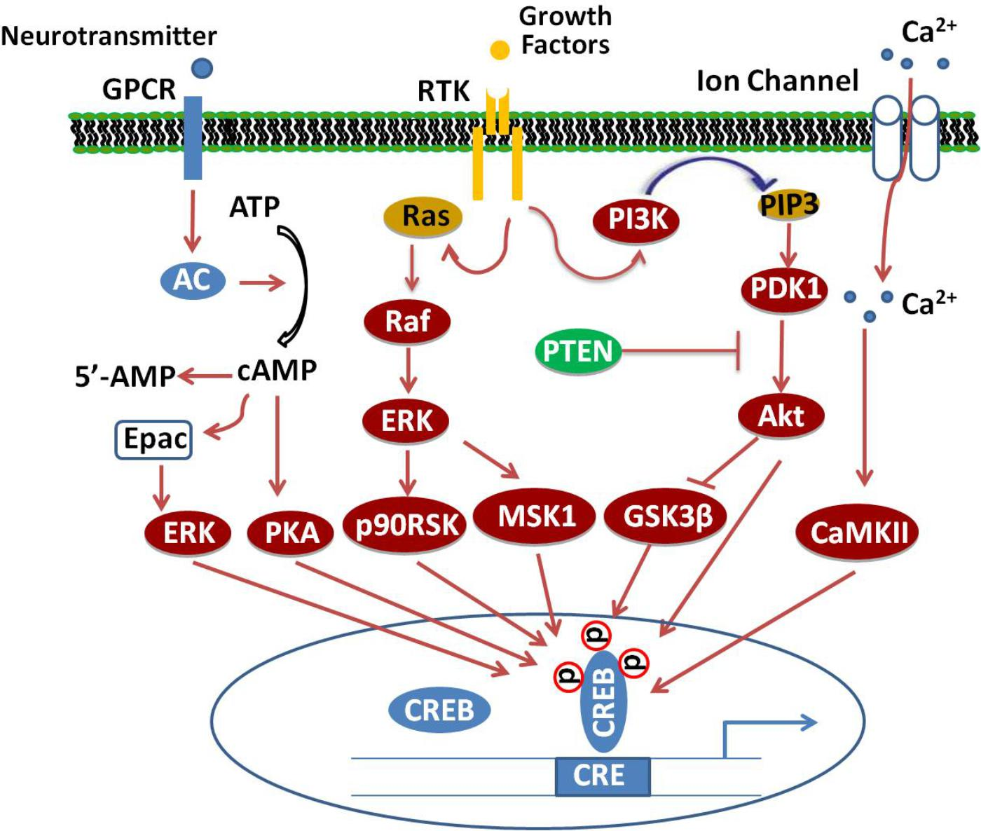
Secondary Messengers
Secondary messenger system exists in plants to transmit the primary elicitation signal of pathogen and/or host.
These are:
- • Ca²⁺ ion influx
- •Protein phosphorylation
- •cAMP
- •Active oxygen species
- •Salicylic acid
- •Methyl Jasmonic and Jasmonic Acid
- •Ethylene
- •Nitric Oxide
- Seminar 3. Biochemical markers related to disease resistance. Choice and application

The fungus Fusarium oxysporum f. sp. Cubense (FOC), is a serious constraint both to the commercial production of banana and cultivation for subsistence agriculture. Chemical control is not economically effective and is also hazardous to the environment and human health. Breeding for disease resistance is an alternative strategy, which leads to the development of resistance clones. Field evaluation is the most reliable method of screening for disease resistance, but it is demanding in terms of cost, manpower and space requirements. Another approach of screening hybrids at the sucker's stage (planting material) through biochemical markers has been found to be effective in early identification of resistant hybrids. The resistance mechanisms involving the role of phenol, PAL, oxidative enzymes like peroxidase (PO), polyphenol oxidase (PPO), superoxide dismutase (SOD), catalase and PR-proteins like chitinase, β-1-3 glucanase were studied and they showed relatively higher activity in resistant hybrids than susceptible hybrids. Isozyme analysis of peroxidase (PO) and polyphenol oxidase (PPO) was also carried out in cultivars and hybrids, which revealed the induction of specific isoforms in the resistant hybrids upon challenge inoculation. This could be a useful tool

Seminar 4. Biochemical markers of disease resistance 4. Extraction DNA. Main principles.
. The resistance mechanisms involving the role of phenol, PAL, oxidative enzymes like peroxidase (PO), polyphenol oxidase (PPO), superoxide dismutase (SOD), catalase and PR-proteins like chitinase, β-1-3 glucanase were studied and they showed relatively higher activity in resistant hybrids than susceptible hybrids. Isozyme analysis of peroxidase (PO) and polyphenol oxidase (PPO) was also carried out in cultivars and hybrids, which revealed the induction of specific isoforms in the resistant hybrids upon challenge inoculation. This could be a useful tool for early identification of F. oxysporum f. sp. cubense resistance banana clones.
Seminar 5. Signal responses - massive changes in gene expression. Structural Defenses. Biochemical relationship in resistant and susceptible cultivars.
- Non-protein amino acids: Many plants also contain unusual amino acids called non- protein amino acids that incorporated into proteins but are present as free forms and act as protective defensive substances .
- For examples, canavanine and azetidine-2-carboxylic acid are close analogs of arginine and proline respectively.
- They exert their toxicity in various ways.
- Some block the synthesis of or uptake of protein amino acid while others can be mistakenly incorporated in to proteins.
- After ingestion, canavanine is recognized by herbivore enzyme that normally binds arginine to the arginine transfer RNA molecule and so become incorporated in to proteins in place of arginine.
- The usual result is a non-functional proteins because either its tertiary structure or it catalytic site is disrupted .
- Plants that synthesize non-protein amino acids are not susceptible to the toxicity of these compounds but gain defense to herbivorous animals, insects and pathogenic microbes.
- Also, a number of plants including Arabidopsis uses Arginine as a storage and transport form of N and proline as a compatible solute in the defense against abiotic stresses causing water deprivation

Seminar 5. Analysis of different types of nuclear acids.

Basic structure
Nucleic acids are polynucleotides—that is, long chainlike molecules composed of a series of nearly identical building blocks called nucleotides. Each nucleotide consists of a nitrogen-containing aromatic base attached to a pentose (five-carbon) sugar, which is in turn attached to a phosphate group. Each nucleic acid contains four of five possible nitrogen-containing bases: adenine (A), guanine (G), cytosine (C), thymine (T), and uracil (U). A and G are categorized as purines, and C, T, and U are collectively called pyrimidines. All nucleic acids contain the bases A, C, and G; T, however, is found only in DNA, while U is found in RNA. The pentose sugar in DNA (2′-deoxyribose) differs from the sugar in RNA (ribose) by the absence of a hydroxyl group (―OH) on the 2′ carbon of the sugar ring. Without an attached phosphate group, the sugar attached to one of the bases is known as a nucleoside. The phosphate group connects successive sugar residues by bridging the 5′-hydroxyl group on one sugar to the 3′-hydroxyl group of the next sugar in the chain. These nucleoside linkages are called phosphodiester bonds and are the same in RNA and DNA.

Biochemical properties

Denaturation
The strands of the DNA double helix are held together by hydrogen bonding interactions between the complementary base pairs. Heating DNA in solution easily breaks these hydrogen bonds, allowing the two strands to separate—a process called denaturation or melting. The two strands may reassociate when the solution cools, reforming the starting DNA duplex—a process called renaturation or hybridization. These processes form the basis of many important techniques for manipulating DNA. For example, a short piece of DNA called an oligonucleotide can be used to test whether a very long DNA sequence has the complementary sequence of the oligonucleotide embedded within it. Using hybridization, a single-stranded DNA molecule can capture complementary sequences from any source. Single strands from RNA can also reassociate. DNA and RNA single strands can form hybrid molecules that are even more stable than double-stranded DNA. These molecules form the basis of a technique that is used to purify and characterize messenger RNA (mRNA) molecules corresponding to single genes.

Ultraviolet absorption
DNA melting and reassociation can be monitored by measuring the absorption of ultraviolet (UV) light at a wavelength of 260 nanometres (billionths of a metre). When DNA is in a double-stranded conformation, absorption is fairly weak, but when DNA is single-stranded, the unstacking of the bases leads to an enhancement of absorption called hyperchromicity. Therefore, the extent to which DNA is single-stranded or double-stranded can be determined by monitoring UV absorption.

Chemical modification
After a DNA molecule has been assembled, it may be chemically modified—sometimes deliberately by special enzymes called DNA methyltransferases and sometimes accidentally by oxidation, ionizing radiation, or the action of chemical carcinogens. DNA can also be cleaved and degraded by enzymes called nucleases.

Seminar 6. Utilization of pigmented cells and phytoalexins as biochemical markers for screening resistance .

Higher Plant–Lower Plant Interactions: Phytoalexins and Phytotoxins.

The Phytoalexin Concept
The phytoalexin concept of disease resistance has undoubtedly led to one of the major developments in physiological plant pathology of the last 25 years and it has probably stimulated more research into the mechanismsof disease resistance in plants than any other single idea. Today, the biochemical aspects of these antifungal agents are well known and only a summary is needed here. It should, however, be emphasized that physiological, ultrastructural and pathological aspects of phytoalexin synthesis are not yet fully documented and although it is widely accepted that phytoalexins have a place in disease resistance, many aspects of their production and metabolism in vivo are not yetfully understood. Before discussing the present state of the phytoalexin field, it is worth restating the main tenets ofthe theory, as postulated by Müller and Börger in 1941 from their studies of the reaction of potato varieties to virulent and avirulent strains of Phytophthora. These tenets are as follows:
(1)
A phytoalexin is a compound which inhibits the developmentof the fungus in hypersensitive tissues and is formed or activated only when the host plants come in contact withthe parasite.
(2)
The defence reaction occurs only in living cells.
(3)
The inhibitory agent is a discrete chemical substance, a product of the host cell.
(4)
The phytoalexin is non-specific in its toxicity towardsfungi; however, fungal species may be differentially sensitive to it.
(5)
The basic response in both resistant and susceptible cells is the same, the basis of differentiation between resistant and susceptible hosts being the speed of formation ofthe phytoalexin.
(6)
The defence reaction is confined to the tissue colonizedby the fungus and its immediate neighbourhood.
(7)
The resistant state is not inherited; it is developed after the fungus has attempted infection. The sensitivity of the host cell which determines the speed of the host reaction is specific and genotypically determined.
As already mentioned, belief in the phytoalexin theory was not vindicated until 20 years later when Cruickshank and Perrin (1960) crystallized and chemically characterized the first phytoalexin; this waspisatin, a pterocarpan derivative produced by pods of Pisum sativum inoculated with conidia of the brown rot funus, Monilinia fructicola. Cruickshank and Perrin (1964) were able to show that pisatin fulfulled all the criteria required by Müller and Börger's theory and this substance remains one of the most fully investigated phytoalexins known today. Subsequent studies soon established that other legumes, particularly Phaseolus vulgaris, produced similar pterocarpans (e.g. phaseollin) on fungal inoculation. At the same time reconsideration of compoundsisolated from diseased plants in other families showed that phytoalexin production is a feature of the Convolvulaceae (ipomeamarone from infected sweet potato) and of the Orchidaceae (orchinol from orchid tubers). Efforts were then directedtowards identifying the compounds formed in response to microbial attack in many other crop plants and a range of chemical structures were found to fit the phytoalexin concept. In particular, several substances, among them the sesquiterpenoid rishitin, were characterized in the potato-blight interaction originally investigated by Müller and Börger. The chemical structures of a representative sample of phytoalexins known today are illustrated in Fig. 10.5.
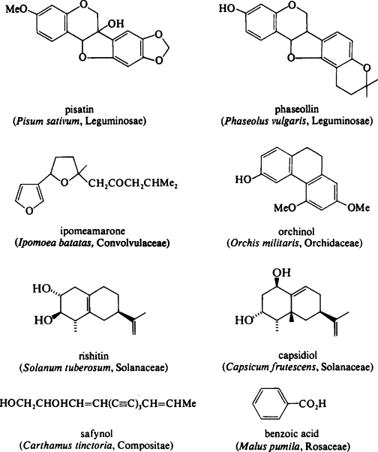

Seminar.7. Optimization and use of RFLP markers for comparative and synteny mapping

DNA fifingerprinting of cereal species and cultivated varieties has a long scientifific history. When
the DNA profifiling technology fifirst came into use, restriction fragment length polymorphism (RFLP) was considered state-of-art. RFLP technology was followed random amplifification of polymorphic DNA (RAPD), followed by amplifified length polymorphism
(AFLP) and most recently use microsatellite markers or single sequence repeats (SSRs) (32). The
advantages of SSR markers are:
- the method is relatively simple and can be automated;
- most of the markers are monolocus and show
Mendelian inheritance;
- SSR markers are highly informative;
- a high number of public SSR primer pairs are available;
- effective cost per genotype and primer (similar to that for RAPD).
Seminar 8. To know and learn: application of Random Amplified Polymorphic DNA (RAPD) in plants breeding for disease resistance

Seminar 9. Role of secondary metabolites in defense mechanisms of plants
- In all natural habitats, plants are surrounded by an enormous number of potential enemies (biotic) and various kinds of abiotic environmental stress.
- Nearly all ecosystems contain a wide variety of bacteria, viruses, fungi, nematodes, mites, insects, mammals and other herbivorous animals, greatly responsible for heavy reduction in crop productivity.
- By their nature, plants protect themselves by producing some compounds called as secondary metabolites.
- Secondary metabolites, including terpenes, phenolics and nitrogen (N) and sulphur (S) containing compounds, defend plants against a variety of herbivores and pathogenic microorganisms as well as various kinds of abiotic stresses.
They include
- glutathione (GSH),
- glucosinolates (GSL),
- phytoalexins,
- thionins,
- defensins and allinin
which have been linked directly or indirectly with the defense of plants against microbial pathogens
Seminar 10. DNA Separation Techniques for different types of DNA

Seminar 11. Types of DNA microarrays
The Future of DNA arrays. Data standards and data exchange. DNA microarrays for transcription factor binding analysis.
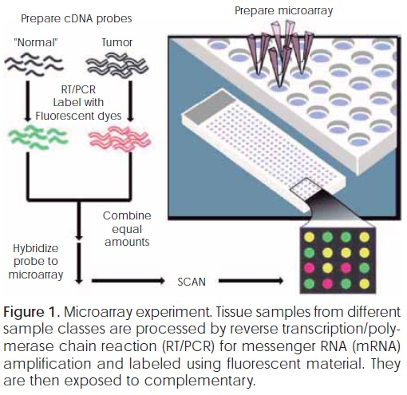
Seminar 12. Strategies for SNP detections strategies for arrays.
Single nucleotide polymorphism (SNP) detection technologies are used to scan for new polymorphisms and to determine the allele(s) of a known polymorphism in target sequences. SNP detection technologies have evolved from labor intensive, time consuming, and expensive processes to some of the most highly automated, efficient, and relatively inexpensive methods. Driven by the Human Genome Project, these technologies are now maturing and robust strategies are found in both SNP discovery and genotyping areas. The nearly completed human genome sequence provides the reference against which all other sequencing data can be compared. Global SNP discovery is therefore only limited by the amount of funding available for the activity. Local, target, SNP discovery relies mostly on direct DNA sequencing or on denaturing high performance liquid chromatography (dHPLC). The number of SNP genotyping methods has exploded in recent years and many robust methods are currently available. The demand for SNP genotyping is great, however, and no one method is able to meet the needs of all studies using SNPs. Despite the considerable gains over the last decade, new approaches must be developed to lower the cost and increase the speed of SNP detection.
Technologies For Global SNP Discovery The main issue with global SNP discovery is that on average, there is one SNP in every 1,000 bp of DNA when two human genomes are compared to each other (The International SNP Map Working Group, 2001). To maximize the chance of finding SNPs, one must be able to scan 1,000 bp pieces of DNA in a generic way. The first attempt to identify SNPs randomly in the human genome was to scan for alterations in restriction sites in the genome (Botstein et al., 1980). Although the actual sequence variation
Seminar 13. Preparation of DNA chip and the experiment
DNA microarray technologies, such as cDNA and oligonucleotide microarrays, promise to revolutionize biological research and further our understanding of biological processes. Due to the complex nature and sheer amount of data produced from microarray experiments, biologists have sought the collaboration of experts in the analytical sciences, including statisticians, among others. However, the biological and technical intricacies of microarray experiments are not easily accessible to analytical experts. One aim for this review is to provide a bridge to some of the relevant biological and technical aspects involved in microarray experiments. While there is already a large literature on the broad applications of the technology, basic research on the technology itself and studies to understand process variation remain in their infancy.

Danh V. Nguyen, A. Bulak Arpat, Naisyin Wang and Raymond J. Carroll
Biometrics DNA Microarray Experiments: Biological and Technological Aspects
Vol. 58, No. 4 (Dec., 2002), pp. 701-717 (17 pages)

Seminar 14. Marker-assisted backcrossing (MABC). Marker assisted pyramiding
Backcrossing is used in plant breeding to transfer favourable traits from a donor plant into an elite genotype (recurrent parent). In repeated crossings the original cross is backcrossed with the recurrent parent until most of the genes stemming from the donor are eliminated (Becker1993). However, the donor segments attached to the target allele can remain relatively large, even after many backcrossing generations. In order to minimize this linkage drag, marker assays can be of advantage.
There are three levels of selection in which markers may be applied in backcross breeding. Markers can be used in the context of MABC to either control the target gene (foreground selection) or to accelerate the reconstruction of the recurrent parent genotype (background selection) and to select backcross progeny having the target gene with tightly- linked flanking markers in order to minimize linkage drag (recombinant selection).
According to Frisch et al. (1999) in a computer simulation MAS can reconstruct a
level of recurrent parent genome in BC3 which would only be reached in BC7 without the use of markers.
However, the authors also state that large numbers of marker data points are required to achieve such results. MABC is especially efficient if a single allele is to be transferred into a different genetic background, for example, in order to improve an existing variety for a specific trait. To overcome the limitation of only being able to improve existing elite genotypes, other approaches like marker-assisted recurrent selection(MARS) have to be considered.
Marker-assisted recurrent selection (MARS): The improvement Of complex traits Via phenotypic recurrent selection is generally possible, but the long selection cycles impose restrictions on the practicability of this breeding method. With the use of markers, recurrent selection can be accelerated considerably and several selection-cycles are possible within one year, accumulating favourable QTL alleles in the breeding population.
- Pyramiding may involve combining genes from more than two parents. For example, combined genes originating from three parents for rice blast and stripe rust in barley, respectively. MAS pyramiding was also proposed as an effective approach to produce three-way F₁ cereal hybrids with durable resistance.
The most widespread application for pyramiding has been for combining multiple disease resistance genes (i.e. combining qualitative resistance genes together into a single genotype). The motive for this has been the development of ‘durable’ or stable disease resistance since pathogens frequently overcome single-gene host resistance over time due to the emergence of new plant pathogen races. Some evidence suggests that the combination of multiple genes (effective against specific races of a pathogen) can provide durable (broad spectrum) resistance. The ability of a pathogen to overcome two or more effective genes by mutation is considered much lower compared with the ‘conquering’ of resistance controlled by a single gene. In the past, it has been difficult to pyramid multiple resistance genes because they generally show the same phenotype, necessitating a progeny test to determine which plants possess more than one gene. With linked DNA markers, the number of resistance genes in any plant can be easily determined. The incorporation of quantitative resistance controlled by QTLs offers another promising strategy to develop durable disease resistance.
Seminar 15. Advantages of MAS over conventional methods.QTL applications in breeding
a- Gene stacking for a single trait: MAS allows breeders to identify the presence of multiple genes/alleles related to a single trait, when the alleles do not exert individually detectable effects on the expression of the trait. E.g: when one gene confers
resistance to a specific disease, breeders would be
unable to use traditional phenotypic screening to add another gene to the same cultivar in order to increase the durability of resistance. In such cases, MAS would
be the only feasible option, provided markers are available for such genes.
b- Early detection:MAS allows alleles for desirable traits to be detected early i.e in the seedling stage itself well before the trait is expressed phenotypically. This benefit can be particularly important in slow growing and long duration crops.
c- Recessive genes: MAS allows breeders to identify heterozygous plants that carry a recessive allele of interest whose presence cannotbe detected phenotypically. In traditional breeding approaches, an extra step of selfing is required to detect phenotypes associated with recessive genes
d- Heritability of traits: MAS is mainly useful in selection for traits with low heritability up to a point, gains from MAS increase with decreasing heritability.
e- Seasonal considerations: MAS offers potential savings compared with conventional selection when it is necessary to screen for traits whose expression depends on seasonal parameters. Using molecular markers, at any time of the year, breeders can screen
for the presence of an allele (or alleles) associated with traits that are expressed only during certain growing seasons. For example, CIMMYT’s wheat breeding station in northern Mexico is usually used for screening segregating germplasm for leaf rust resistance.
However, expression of leaf rust is not uniform in all growing seasons. When there are seasons with low expression of leaf rust, markers, if available, can be a valuable alternative as a tool for screening.
f- Geographical considerations: MAS is necessary to screen
for traits whose expression depends on geographical considerations. Using molecular markers,
breeders in one location can screen for the presence of an allele (or alleles) associated with traits expressed only in other locations.
g-Multiple genes, multiple traits: MAS offers
potential savings when there is a need to select for multiple traits simultaneously.
With conventional methods, it is often necessary to conduct separate trials to screen for individual traits.
h- Biological security considerations: MAS provides a potential advantages over selection based on the use of
potentially harmful biological agents (e.g. artificial viral infections or artificial infestations with pathogens), which may require specific security measures.

